**BCSE204P- Design and Analysis of Algorithms Lab**

**E1-Slot-L43-L44 Lab**

**In-Lab Practice (IPS) Exercise-1**

**Name: R. Muhmmad Abrar**

**Register no: 21BRS1713**

**Any one question Output:**

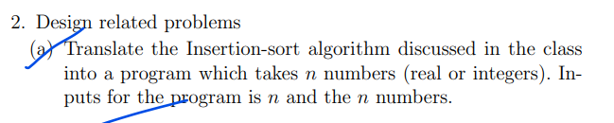

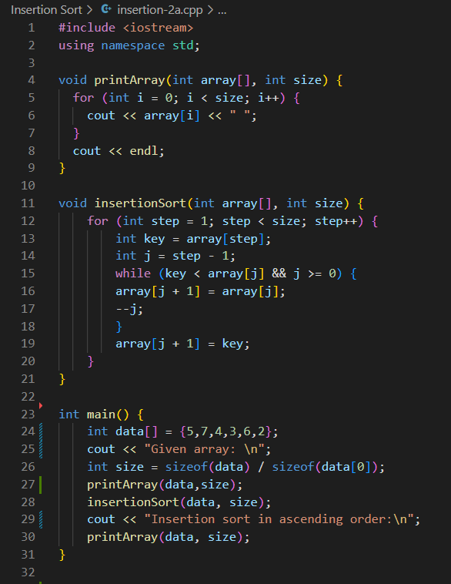

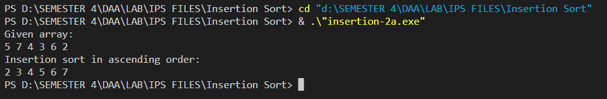

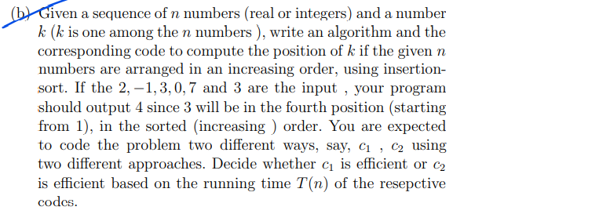

**Approach c1 [LINEAR SEARCH]**

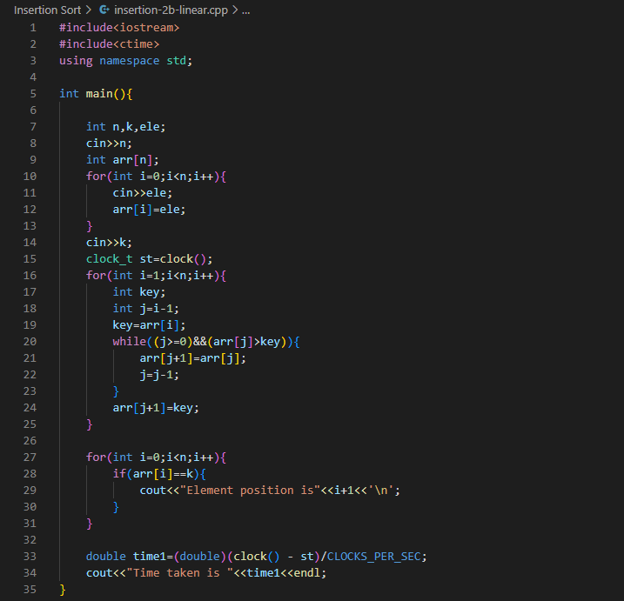

**Approach c2 [BINARY SEARCH]**

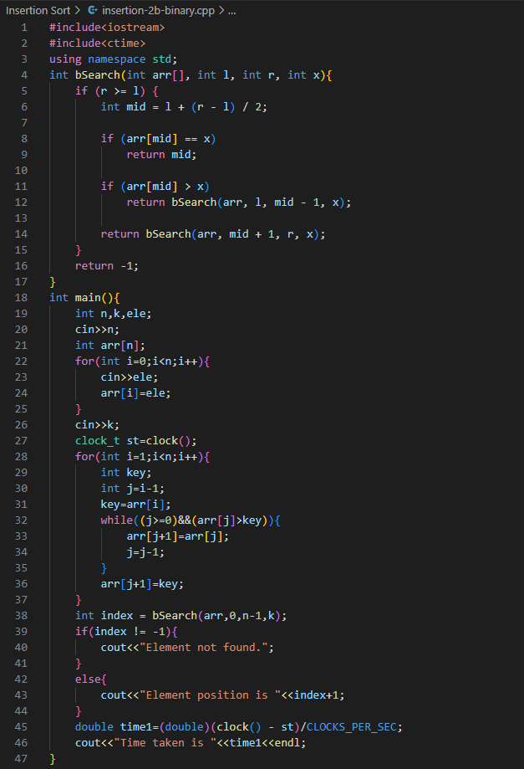

**Outputs:**

**C1[linear search]**

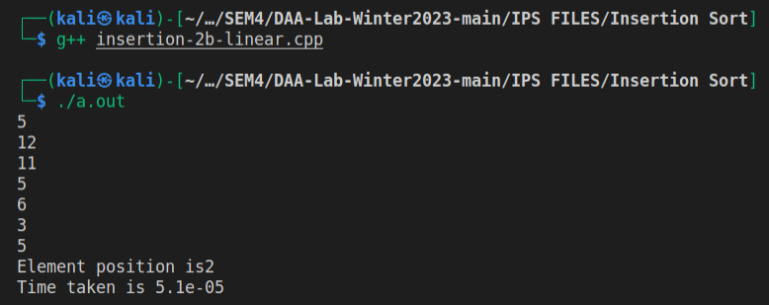

**C2[binary search]**

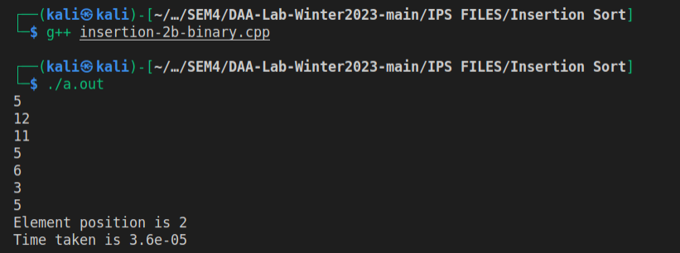

For the same inputs, c2 method seems to provide better results than c1 method.

Thus, Binary search method is more efficient in terms of time complexity.

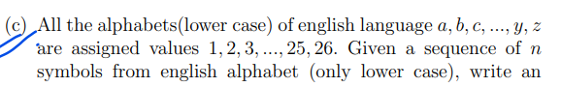

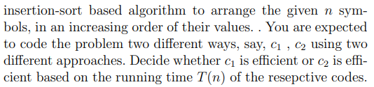

**CODE**

**Approach c1**

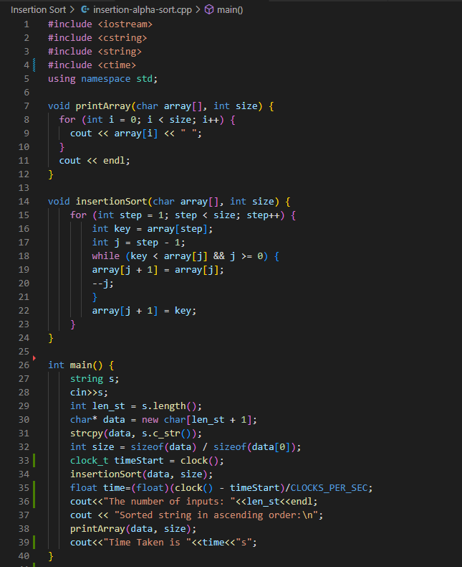

**Approach c2**

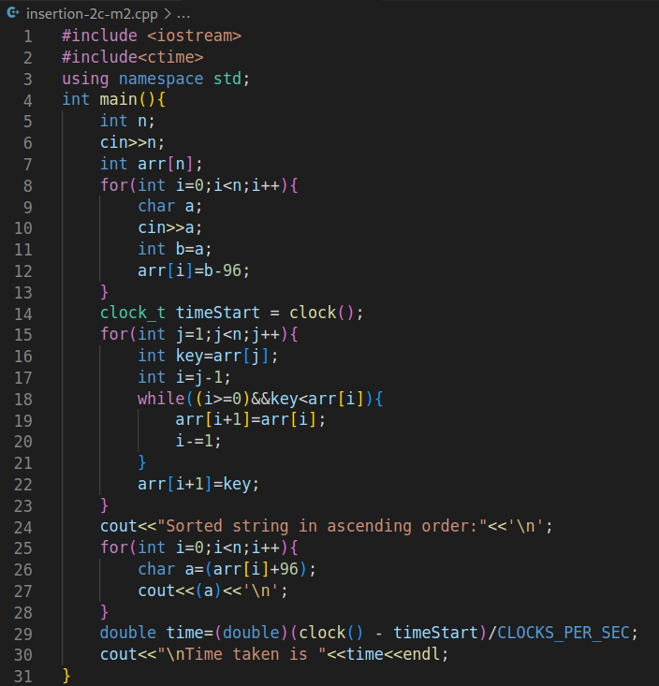

**OUTPUT:**

**Approach c1**

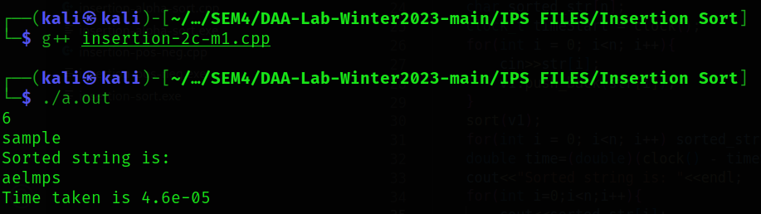

**Approach c2**

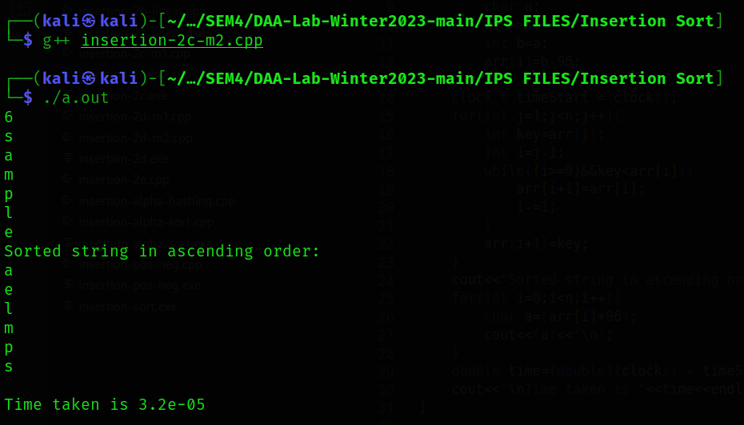

By looking at the time taken by the 2 approaches, I feel that my approach c2 is taking lesser time than approach c1 for the same input. So, approach 2 is more efficient.

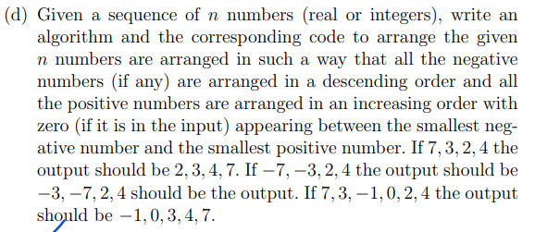

**CODE**

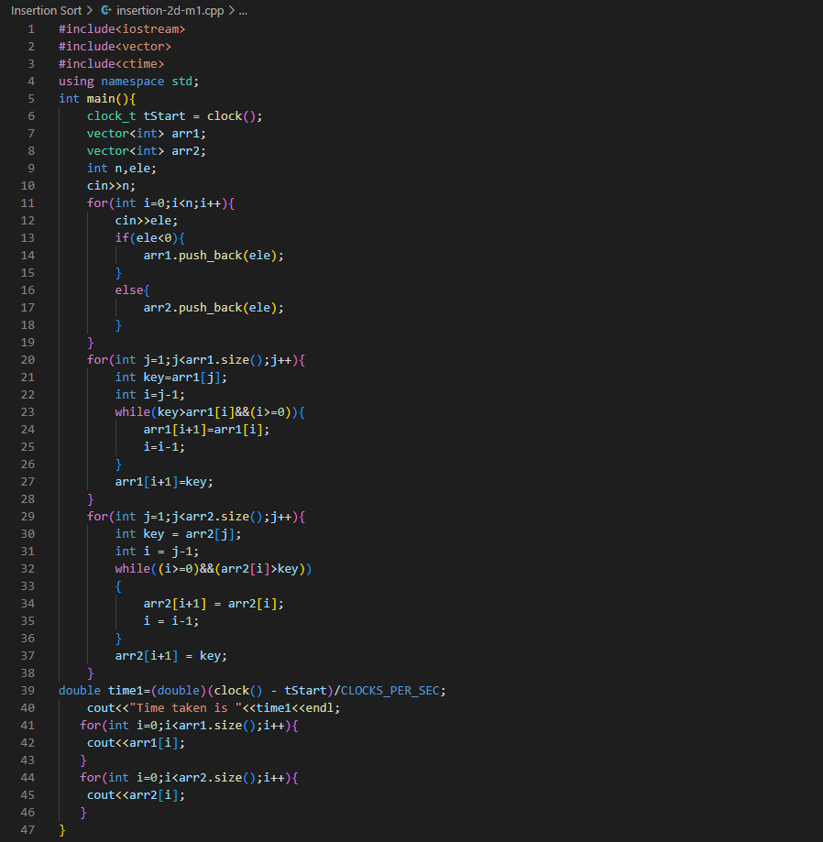

**OUTPUT**

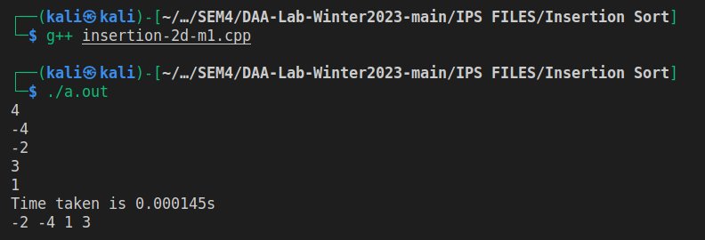

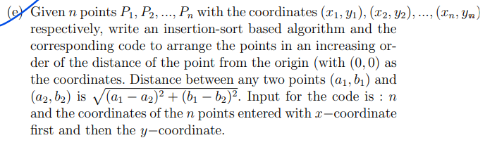

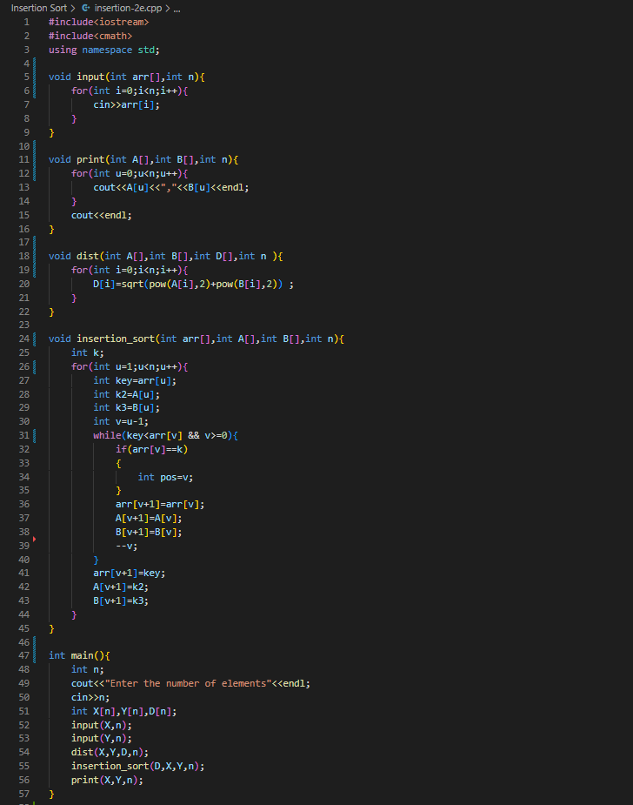

**OUTPUT**

